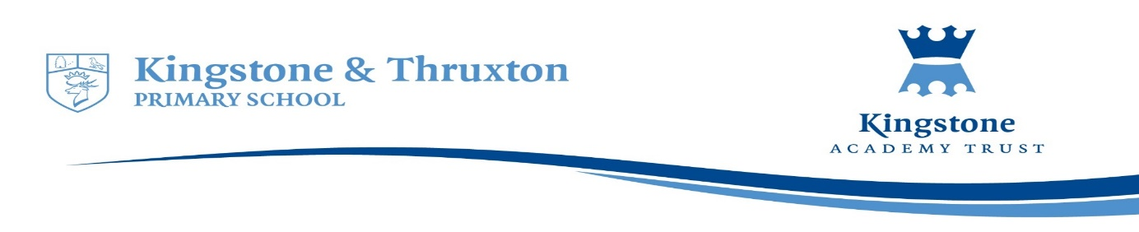

**Kingstone and Thruxton Primary School**

**Art and Design Planning Overview 2024-25**

|  |  |  |  |  |  |  |
| --- | --- | --- | --- | --- | --- | --- |
| **Year Group** | **Autumn 1** | **Autumn 2** | **Spring 1** | **Spring 2** | **Summer 1** | **Summer 2** |
| Reception (Expressive arts and design) | Throughout the year, children are given opportunities to explore and experience a variety of artistic materials and techniques. These opportunities are though adult-led focus sessions and continuous provision activities that vary from being child led or scaffolded by adults. Children are encouraged to return and build on their previous learning and refine their ideas, as well as working collaboratively to share ideas, resources and skills. | | | | | |
| Year 1 | Drawing  Observational Sketching  Focus Artist: Leonardo Da Vinci |  | Painting  Season paintings  Focus Artist: Claude Monet | Printing and Collage  Plant/flower collages  Fruit and vegetable printing  Focus Artist: Picasso |  | 3D  Natural Art  Focus Artist: Andy Goldsworthy |
| Year 2 | Drawing  African Patterns Animal drawings  Focus Artist: Edward Saidi TingaTinga |  | Painting  Landscape and space inspired  Focus Artist:  Alma Thomas | Printing and Collage  GFoL  Flowers  Focus Artist:  Matisse |  | 3D  Using found objects to create art  Focus Artist:  Betye Saar (1926 - present day) |
| Year 3 | Drawing  Focus Artist: Paul Cadden  (Hyper-realism)  Final product: Landscape sketch using different techniques. |  | Painting  Focus Artist: Pablo Picasso  Final Product: Cubism landscape with focus on pairing colours effectively. | Printing (3 weeks)  Focus Artist: Andy Warhol  Finished product: Positive & negative potato and string prints.  Collage (3 weeks)  Focus Artist: Kurt Schwitters  Final product: Portrait collages using photographs. |  | 3D  Focus Artist: Vanessa Hinsley (Mixed Media Art)  Final product: Mixed media abstract 3D canvas. |
| Year 4 | Drawing  Focus Artist: Gary Hodges |  | Painting  Focus Artist: Friedensreich Hundertwasser |  | Printing and Collage  Focus Artist: Njideka Akunyili Crosby | 3D  Focus Artist:  New artist to be picked. |
| Year 5 | Drawing  Focus Artist: Joseph Cornell |  | Painting  Focus Artist: Leah Newton | Printing and Collage  Focus Artist: George Braque |  | 3D  Focus Artist: Zaha Hadid |
| Year 6 | Drawing  Focus Artist: Rembrandt |  | Painting  Focus Artist: Rhiannon Roberts | Printing and Collage  Focus Artist: Andy Warhol & William Morris |  | 3D  Focus Artist: Time Burton & Lorenzo Mattotti |