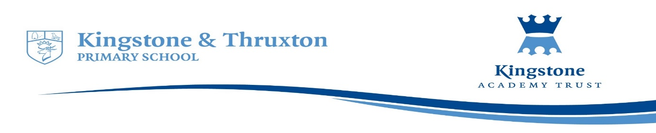

**Kingstone and Thruxton Primary School**

**Design Technology Planning Overview 2022-23**

|  |  |  |  |  |  |  |
| --- | --- | --- | --- | --- | --- | --- |
| **Year Group** | **Autumn 1** | **Autumn 2** | **Spring 1** | **Spring 2** | **Summer 1** | **Summer 2** |
| Reception  (Expressive arts and design) | Throughout the year, children are given opportunities to explore and experience a variety of artistic materials and techniques. These opportunities are though adult-led focus sessions and continuous provision activities that vary from being child led or scaffolded by adults. Children are encouraged to return and build on their previous learning and refine their ideas, as well as working collaboratively to share ideas, resources and skills. | | | | | |
| Year 1 | In Year 1, Children build upon the work they did in Reception. Throughout the year, children are given opportunities to explore and experience a variety of artistic materials and techniques. These opportunities are though adult-led focus sessions and continuous provision activities that vary from being child led or scaffolded by adults. Children are encouraged to return and build on their previous learning and refine their ideas, as well as working collaboratively to share ideas, resources and skills. | | | | | |
|  | | Shoe box puppets and making fruit kebabs | | Junk model castles and making porridge | |
| Year 2 |  | Focus skill: Mechanisms  End product: Christmas card with moving parts |  |  | Focus skill: Textiles  End product:  Wax resist/ tye - dye natural dye |  |
| Year 3 |  | Focus skill: Mechanisms  End product: Pulley system from Year 6 balcony.  Pneumatic monster with a moving mouth. |  |  | Focus skill: Textiles  End product: Woven pencil pouch. |  |
| Year 4 |  | Focus skill: Textiles  End product: Bean bag animal |  |  | Focus skill: Mechanisms  End product: Light up quiz board |  |
| Year 5 |  | Focus skill: Mechanisms  End product: Rainforest animal cams |  |  | Focus skill: Textiles  End product:  Annie Albers |  |
| Year 6 |  | Focus skill: Textiles  End product: Artificial flowers |  |  | Focus skill: Mechanisms  End product: A steady hand game |  |