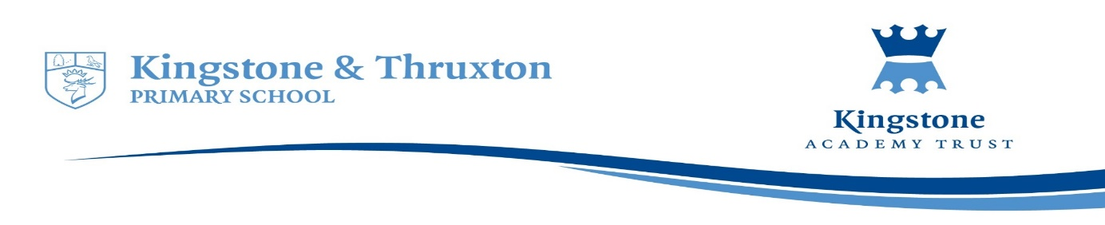

**Kingstone and Thruxton Primary School**

**History Planning Overview 2022-23**

|  |  |  |  |  |  |  |
| --- | --- | --- | --- | --- | --- | --- |
| **Year Group** | **Autumn 1** | **Autumn 2** | **Spring 1** | **Spring 2** | **Summer 1** | **Summer 2** |
| Throughout the half terms where a specific History topic is not assigned, children have regular opportunities to revisit their prior History learning, recapping key concepts, knowledge and skills. Vocabulary from previous History topics remains on display in classrooms and is regularly discussed. Wherever relevant, explicit links are made between previous History learning and current topics. | | | | | | |
| Reception | **How have I changed over time?** | **What and why do people celebrate** | **What’s beneath our feet?** | | **What was different long ago?** | |
| Year 1 | **How have toys changed over time?**  **Why do we wear poppies?** | | **Who has explored the oceans?**  **Christopher Columbus** | | **How has Kingstone changed?** | |
| Year 2 |  | **What is a significant person?**  Why are Florence Nightingale and Mary Seacole significant?  Who was Sarah Forbes Bonetta? | ***Why do some people become significant figures?***  *Katherine Johnson, Neil Armstrong*  *(Jane - Considine unit*  *Find out about these people through story books )* | **Great Fire of London**  **What was the impact of the fire?** |  | **What buildings in Kingstone changed over time and why?**  In depth study of school grounds and Church - significant changes in Victorian Era  **Who is Elgar and why is he significant?** Local significant Victorian |
| Year 3 | **How did life change from Stone Age to Iron Age?** |  | | **What was the impact of WWII on Kingstone?** |  | **What do historical sources teach us about Ancient Egypt?**  (Including a lesson focussing other civilisations from the same time period) |
| Year 4 | **What was life like in the Victorian times and how did things change?** |  | **What was the impact of Roman Empire on Britain?** |  | **What was the impact of Anglo Saxons and Scots on Britian?** |  |
| Year 5 |  |  | **What do historical sources tell us about Ancient Egypt?** |  | **What impact did Vikings have on Britain?** | **Beyond Face Value**  (reliability of sources)  Tudors/ Victorians/W11 linked to Y3 |
| Year 6 |  | **Who are the Maya and what have we learnt from them?** |  | | **What does it mean to be Black and British?** (post 1066) | |

***How have the Ancient Greeks impacted on our life today? From 2025***